EQUATIONS OF STRAIGHT LINES
Remember in your grade 9 you look at straight line functions where the general equation of a straight line was given as$y=mx+c$. The m represents the gradient and the c represents the y-intercept where the line meets the y-axis.
Example: Consider the diagram below showing straight line AB, where A( -3; -4) and B(4 ; 3)
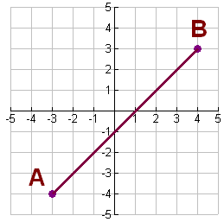
You can see that the line meets the y-axis at -1, hence c = -1.
m= gradient = $\frac{y_{2-y_{1}}}{x_{2-x_{1}}}$
= $\frac{3--4}{4--3}$ = $\frac{3+4}{4+3}$ = $\frac{7}{7}=1$

Hence: Equation of the straight-line becomes:
$y=1x-1$
m c
NB: $y=1x-1$ can be written as$y=x-1$, because of coefficient 1

FINDING THE EQUATION OF A STRAIGHT LINE GIVEN TWO POINTS.

Example: Find the equation of a straight line given the points:
P(2;5) and Q(4;11)
Solution: $y=mx+c$
$m=\frac{11-5}{4-2}=\frac{6}{2}=3$
So, $y=3x+c$, then substitute any one of the two points above
ie P(2;5) $5=3\left(2\right)+c$
$5=6+c$
$c=-1$
Therefore: The equation becomes; $y=3x-1$
EXERCISE 5
- Write down the gradient and y-intercepts of the following lines:
- $y=4x-5$
- $y=-x+2$
- $y=-2x$
- $y=10$
- Find the equation of a straight line TR, where(3;6) and R(-1;-6)

